How Many People Have To Die Before We Take Action?

If I told you two of these people were going to die, but there was something you could do to prevent it, what would you do?

It’s a simple question, but where HAI’s are concerned, the solution is one that is often ignored or brushed aside as too costly or too time consuming.

I guess the real question should be: How much is a human life worth? How about $12.00? With the Halo Disinfection System, that’s the cost of treating a room with the most powerful and effective disinfection control system on the market today.

Traditional cleaning methods, such as a rag and bleach, are not enough. These are most often used incorrectly and just spread the germs around.
But you can treat every room in your facility with a system proven to kill disease-causing pathogens, including MRSA and the difficult to kill, C. diff spores for just $12.00 a room.

The Halo Disinfection System combines a patented 5% hydrogen peroxide-based disinfectants for use with the dry-mist dispensing HaloFogger™ as an easy-to-use, and affordable surface disinfection system. Unlike the ineffective “spray & wipe” approach and expensive disinfecting technologies like UV, the Halo Disinfection System delivers EPA validated hands-free, whole room surface disinfection at a 6-log kill rate for C. difficile spores as well as other deadly pathogens that saves patients’ lives.

Your facility is currently listed as having higher than average rates of MRSA and/or C. diff by the Medicare Compare Data Base, but there is something you can do to change that.

There are 99,000 HAI’s in the United States every year, and 1 in 20 of those people are destined to die, but you have the power in your hands to prevent this unnecessary and tragic loss of life with the simple touch of a button. The time to take action is now.

Won’t you call us today to find out more about the Halo Disinfection System?

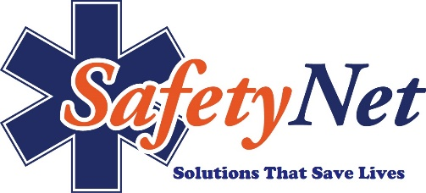
Safety Net, LLC
866-918-8546
SafetyNetAmerica.com

